. function factory:

1.

Code:

// Function factory

function makeMultiplier(multiplier) {

var myFunc = function (x) {

return multiplier \* x;

};

return myFunc;

}

var multiplyBy3 = makeMultiplier(3);

console.log(multiplyBy3(10));

var doubleAll = makeMultiplier(2);

console.log(doubleAll(100));

// Passing functions as arguments

function doOperationOn(x, operation) {

return operation(x);

}

var result = doOperationOn(5, multiplyBy3);

console.log(result);

result = doOperationOn(100, doubleAll);

console.log(result);

result:

30

200

15

200

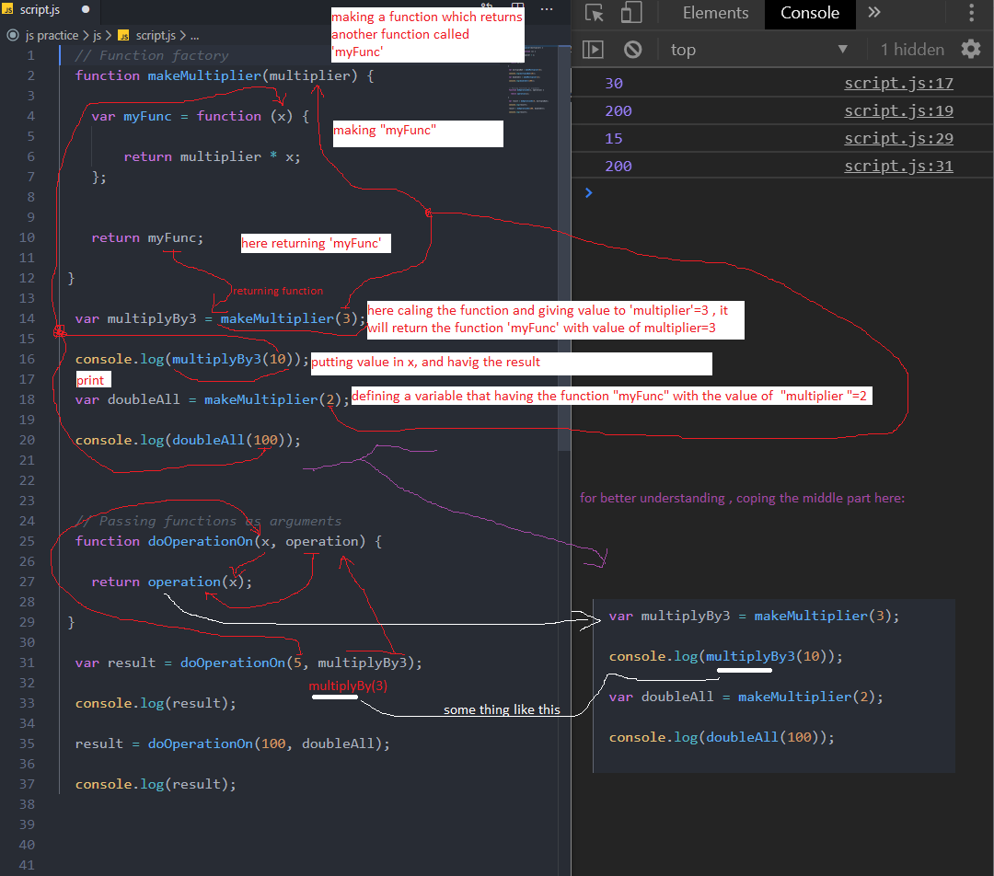

2. 